**1.Create a new process by invoking the appropriate system call. Get the process identifier of the currently running process and its respective parent using system calls and display the same using a C program.**

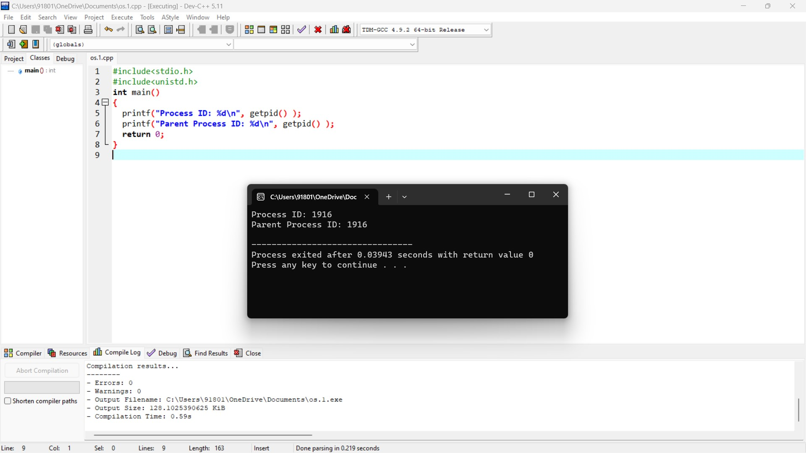

**2.Identify the system calls to copy the content of one file to another and illustrate**

**The same using a C program.**

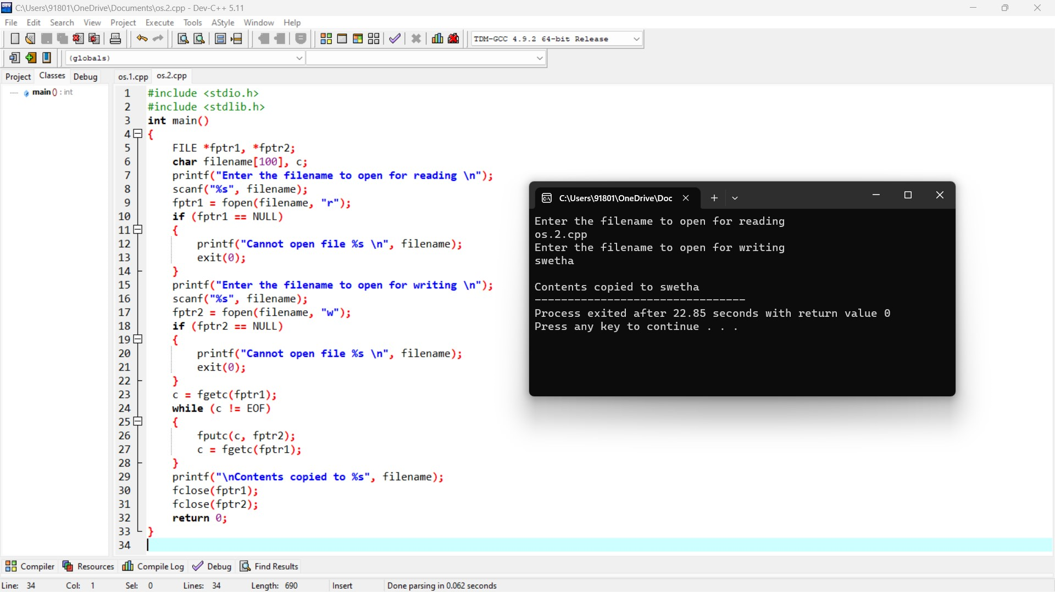

**3. Design a CPU scheduling program with C using First Come First Served technique with the following considerations.**

**a. All processes are activated at time 0.**

**b. Assume that no process waits on I/O devices.**

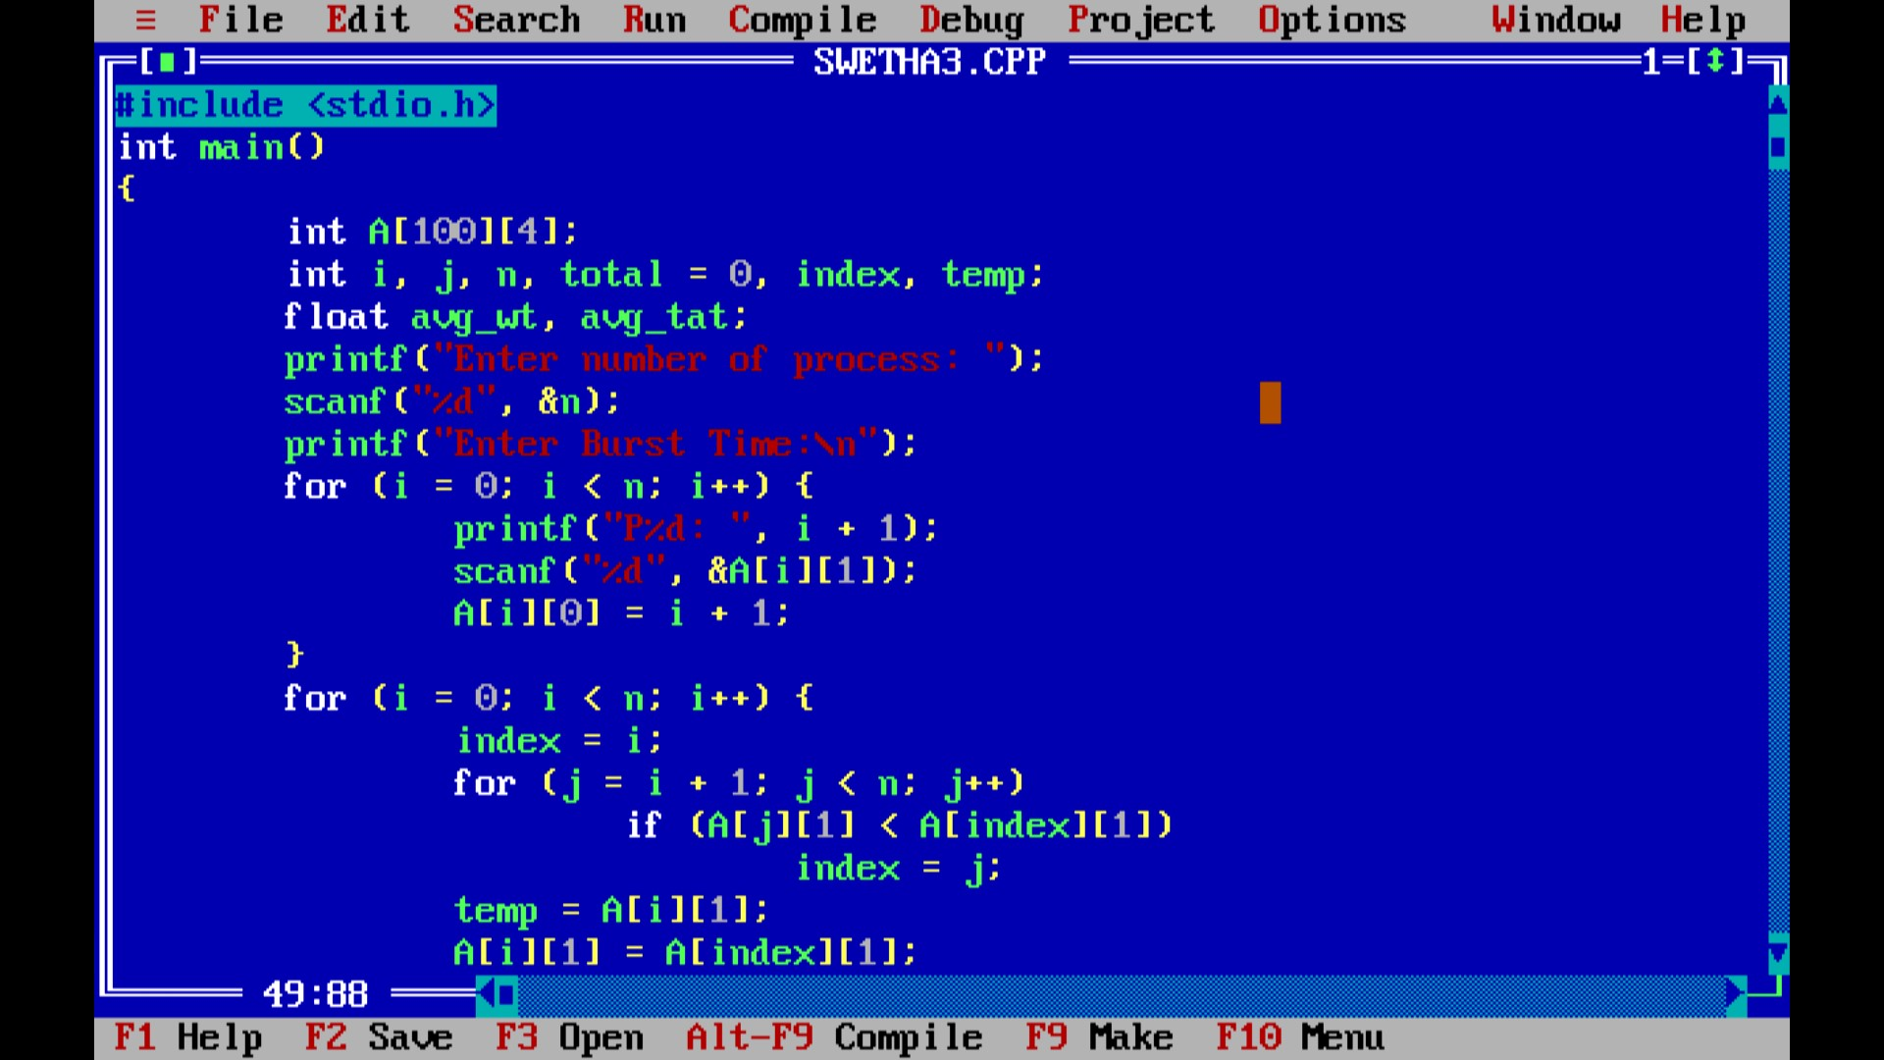

Output

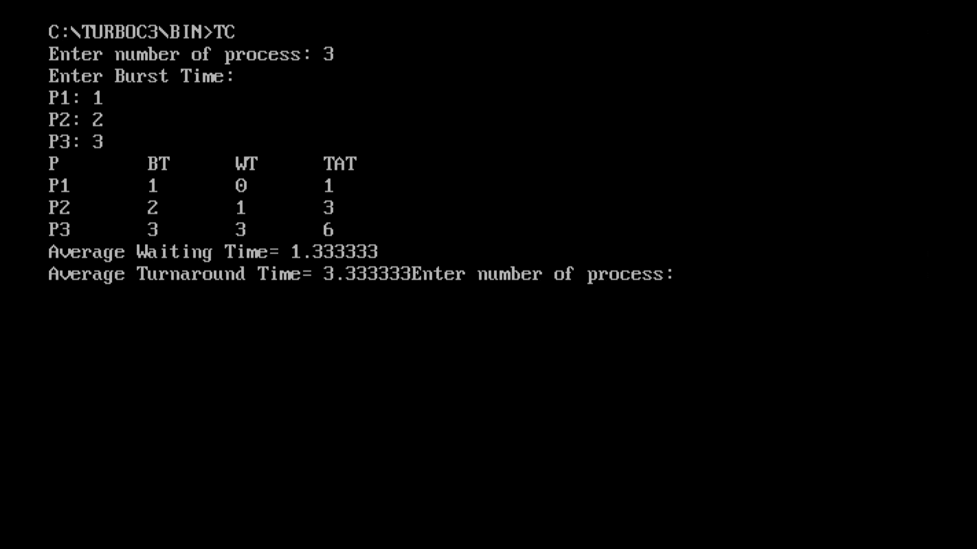

**4. Construct a scheduling program with C that selects the waiting process with the smallest execution time to execute next.**

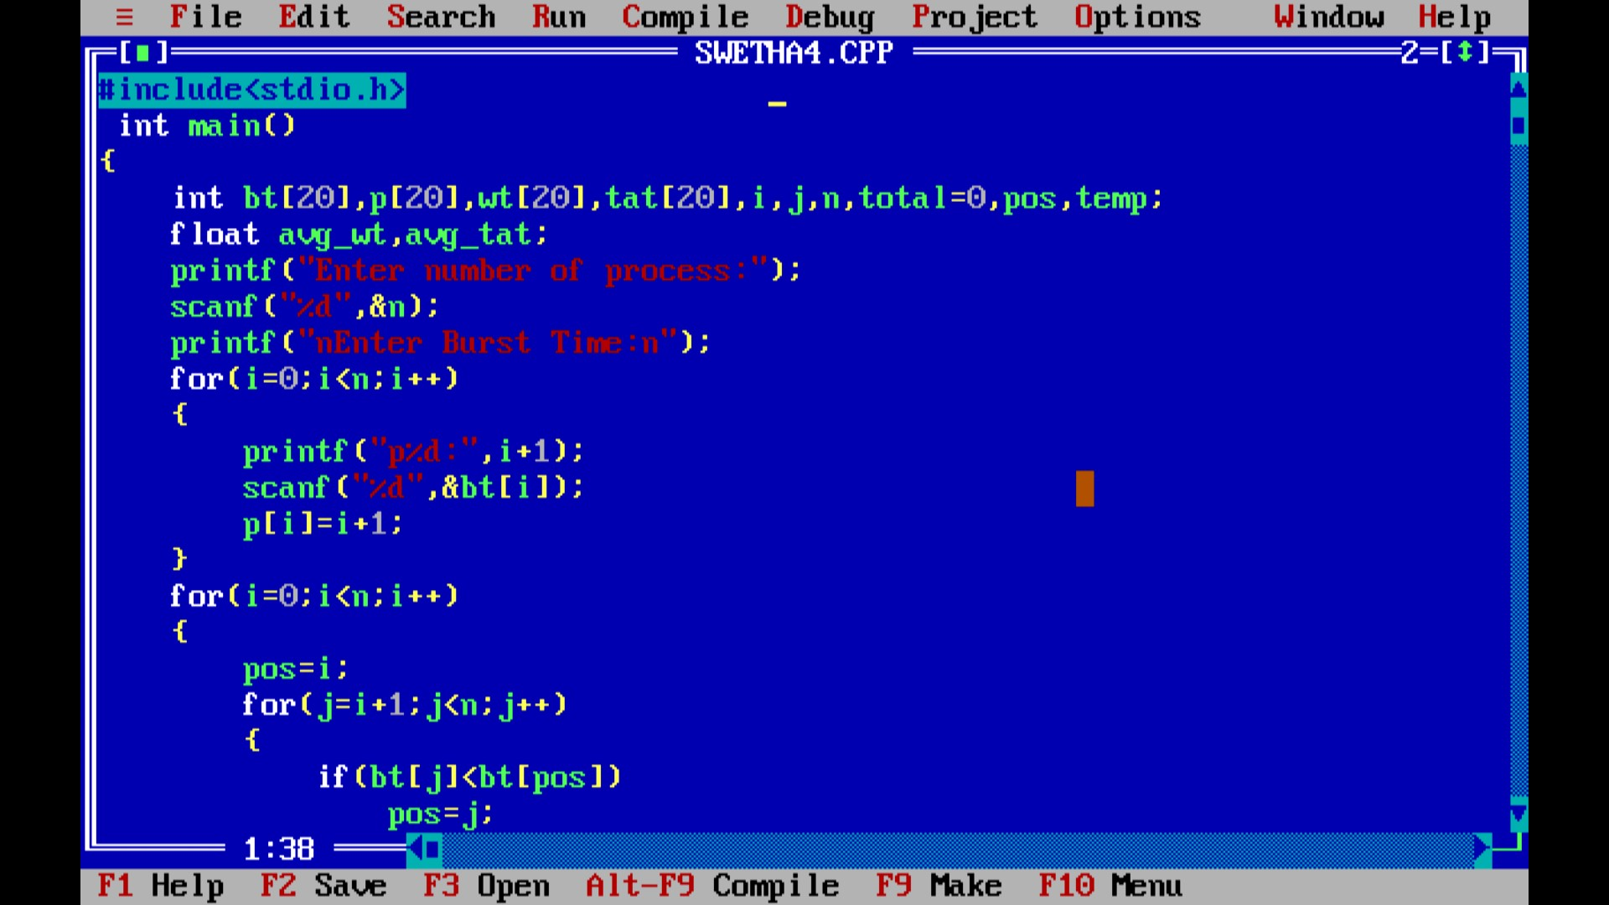

Output

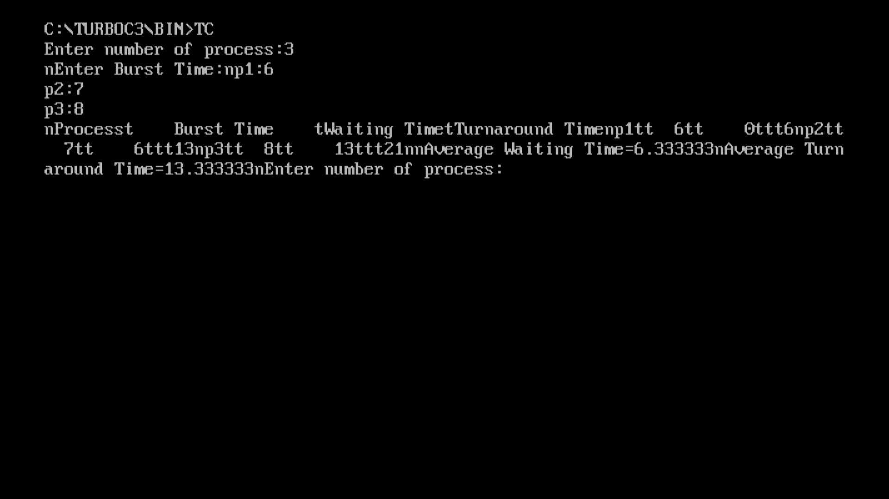

**5. Construct a scheduling program with C that selects the waiting process with the highest priority to execute next.**

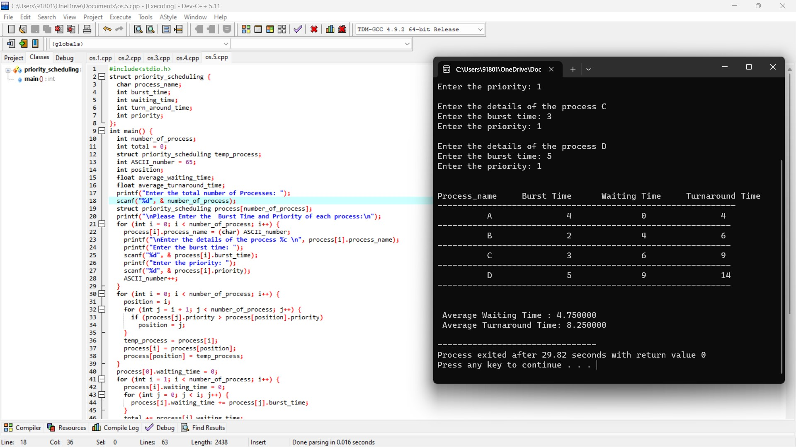

**6. Construct a C program to implement pre-emptive priority scheduling algorithm.**

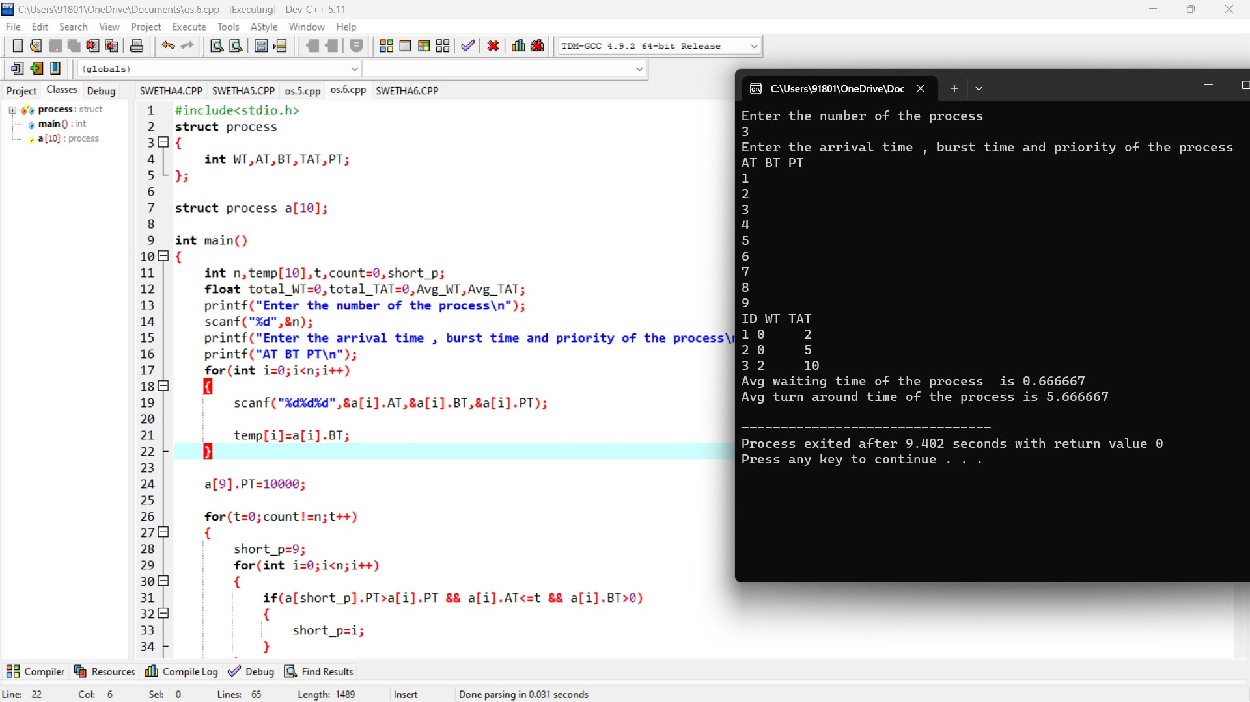

**7. Construct a C program to implement non-preemptive SJF algorithm.**

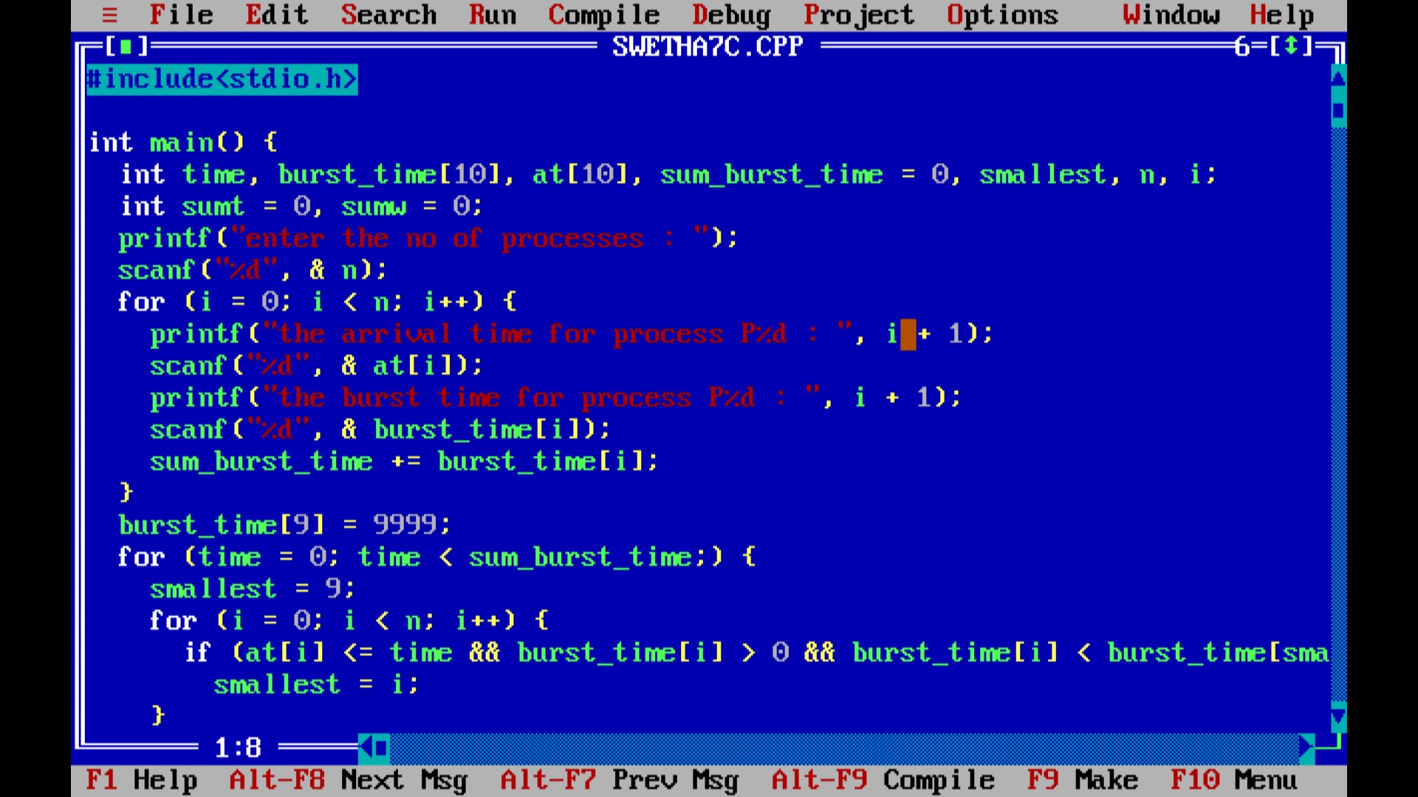

**Output**

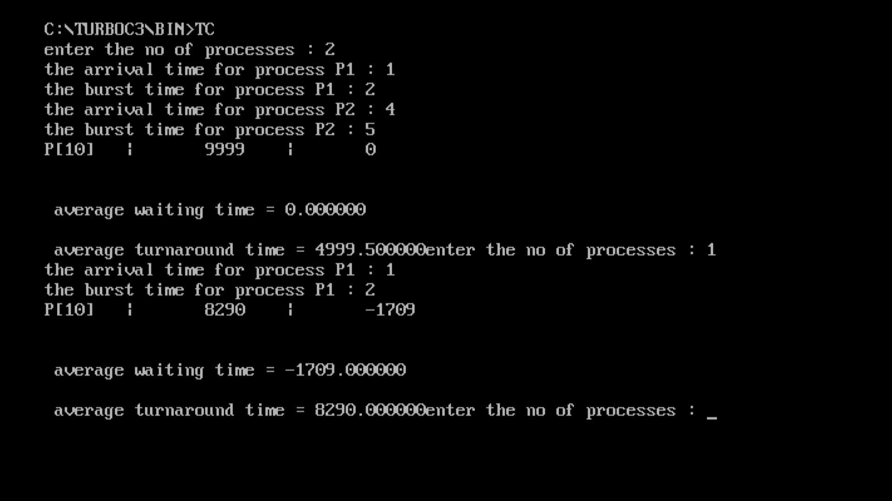

**8. Construct a C program to simulate Round Robin scheduling algorithm with C.**

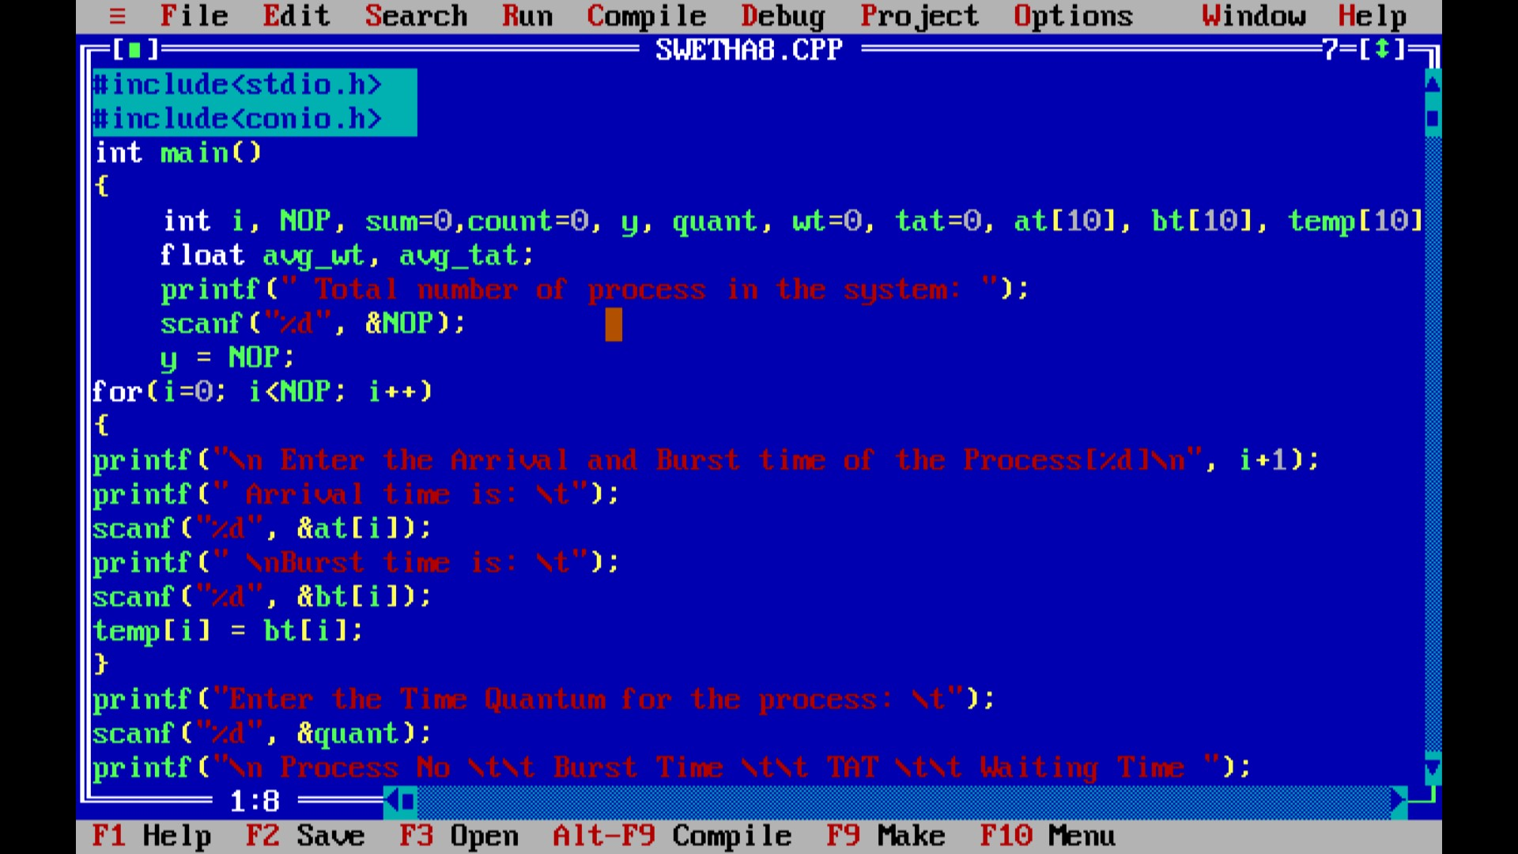

**Output**

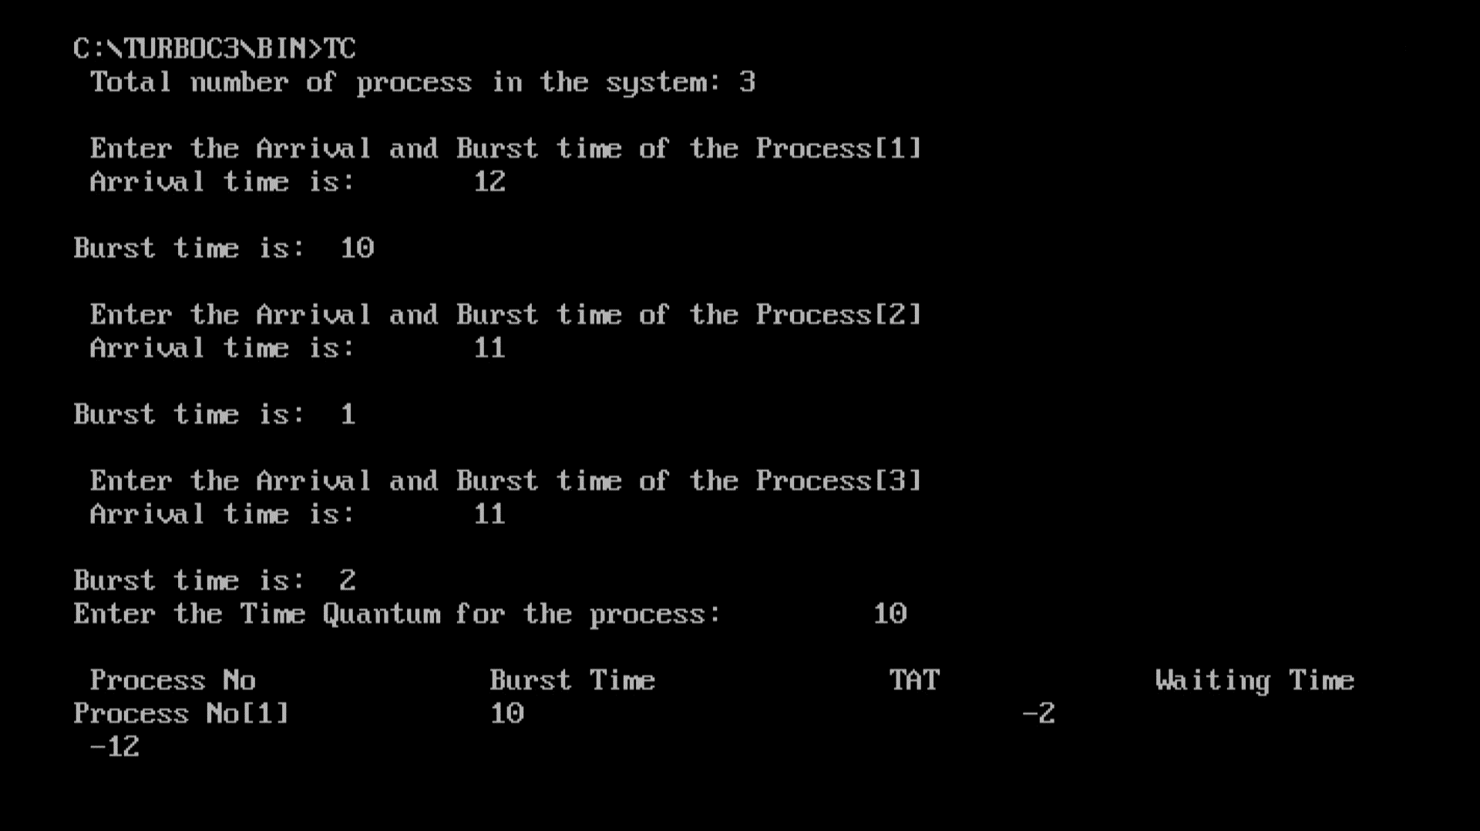

**9. Design a C program to simulate the concept of Dining-Philosophers problem**

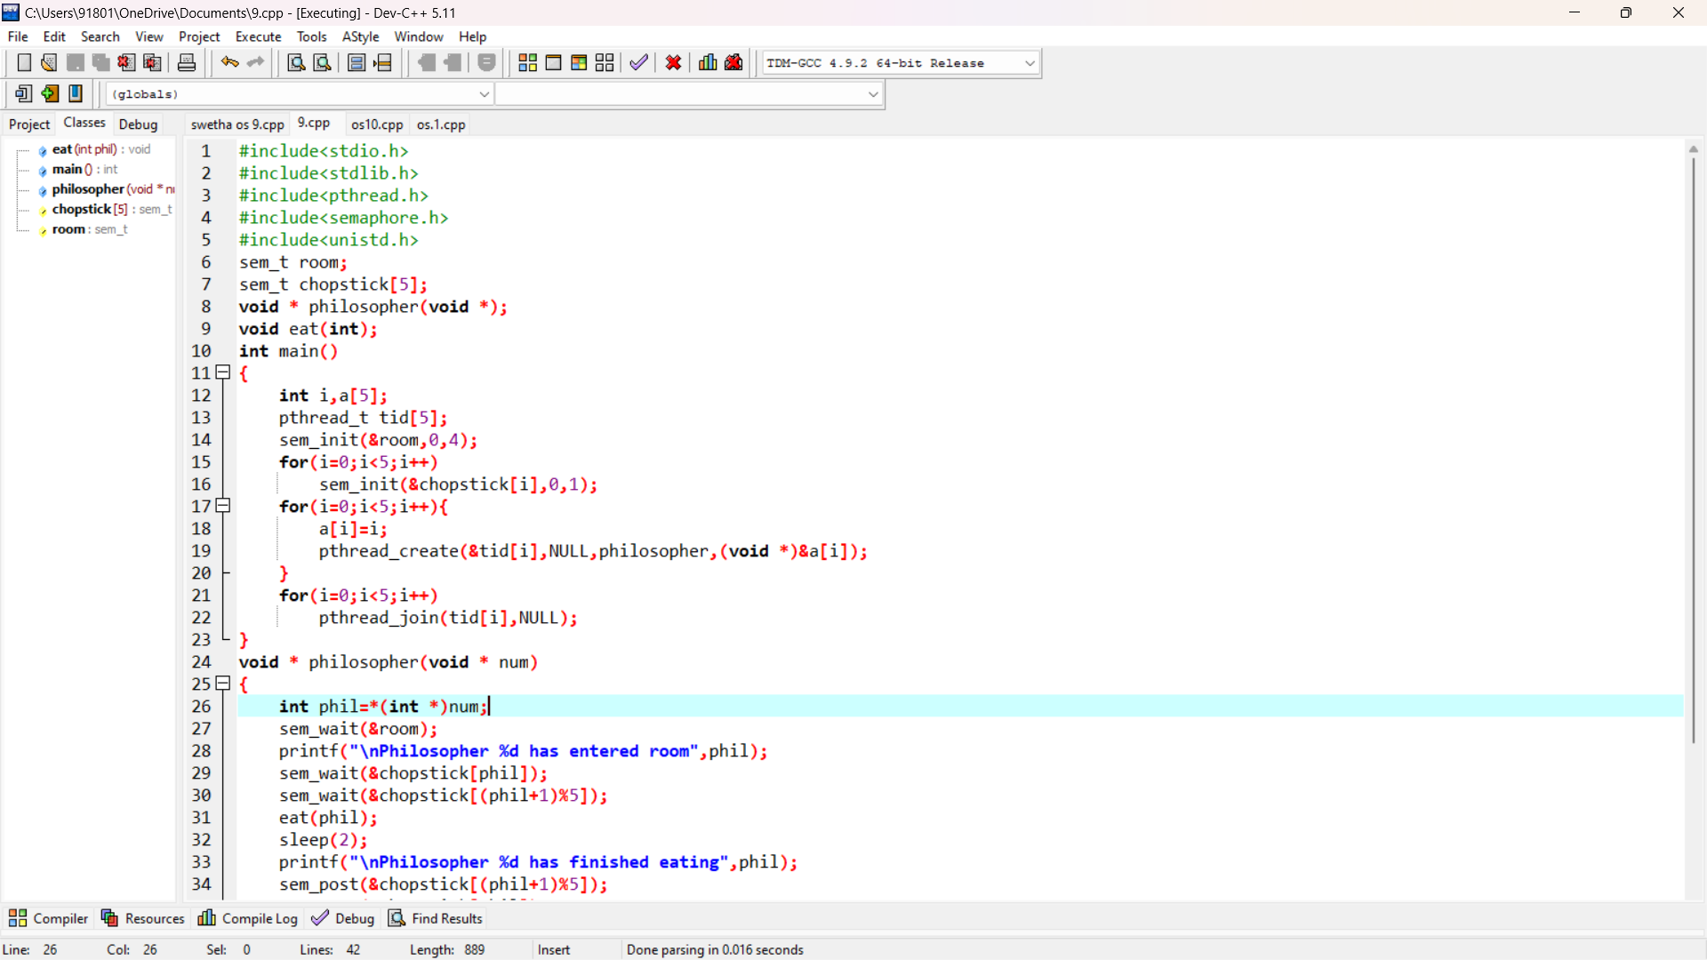

**Output**

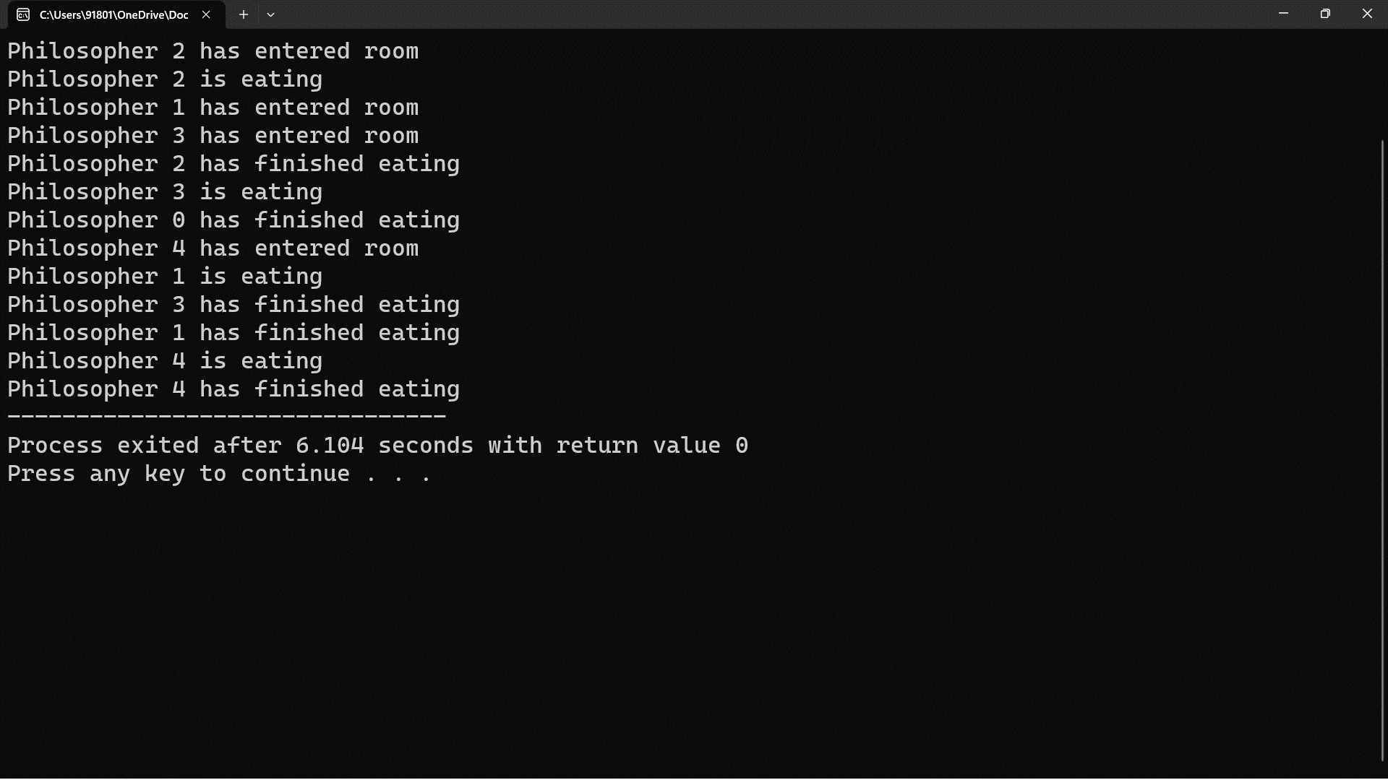

**10. Construct a C program for implementation of memory allocation using first fit strategy.**

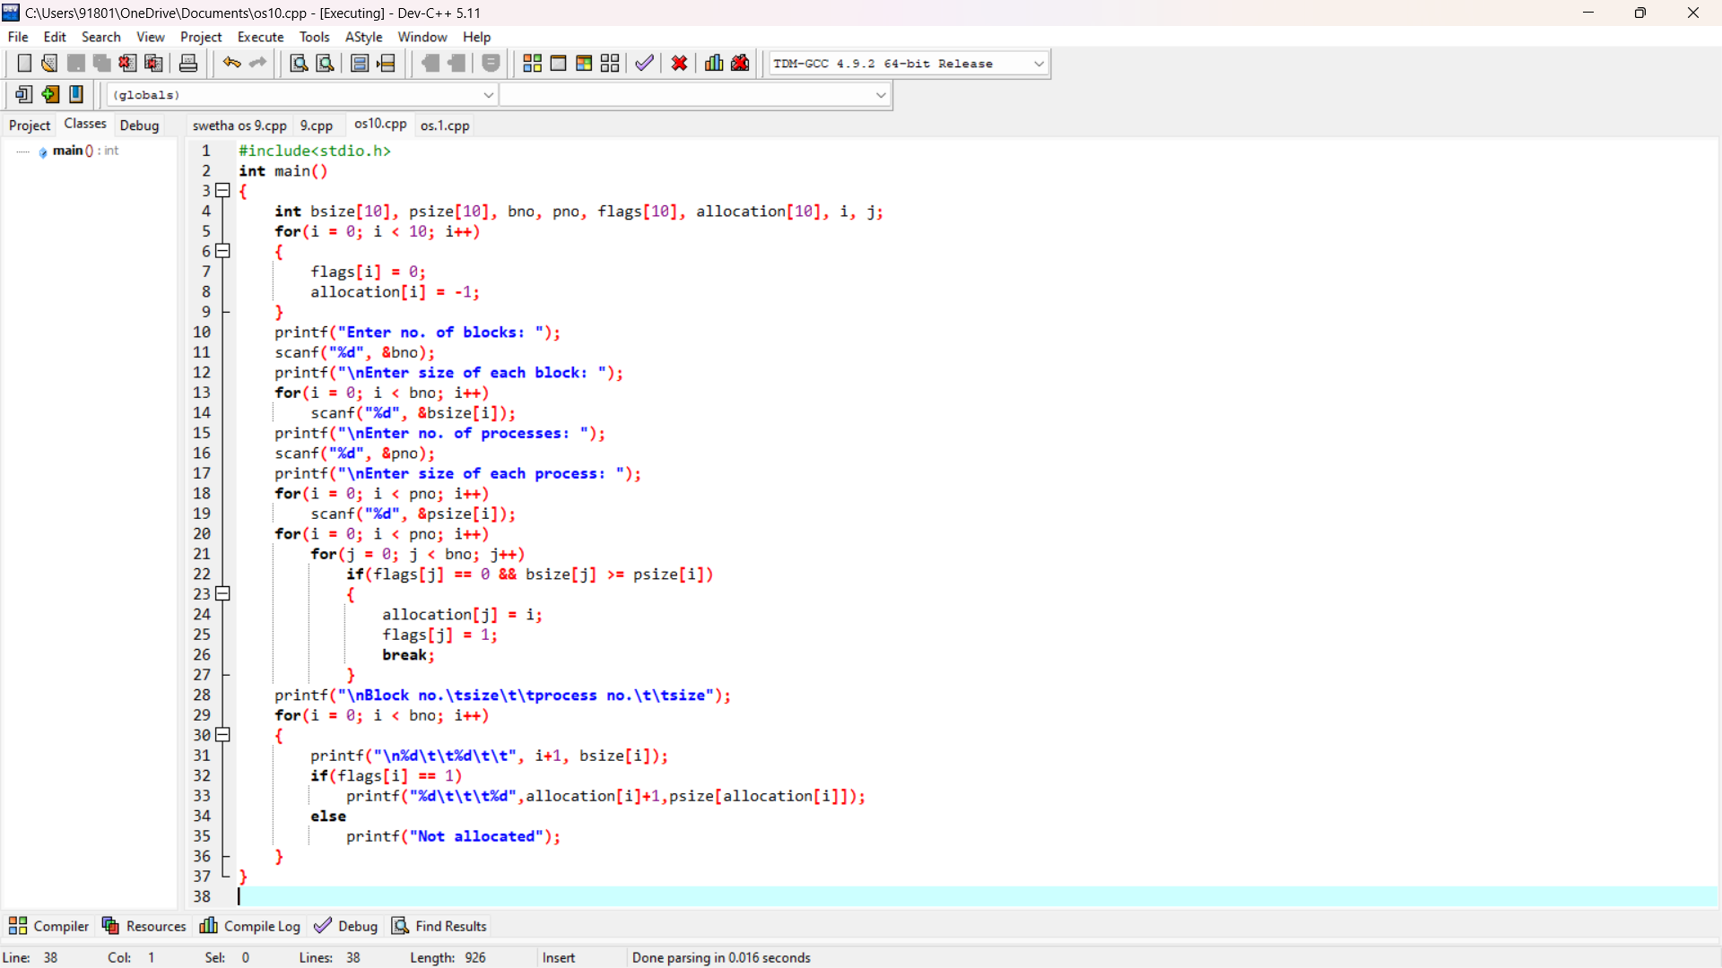

**Output**

